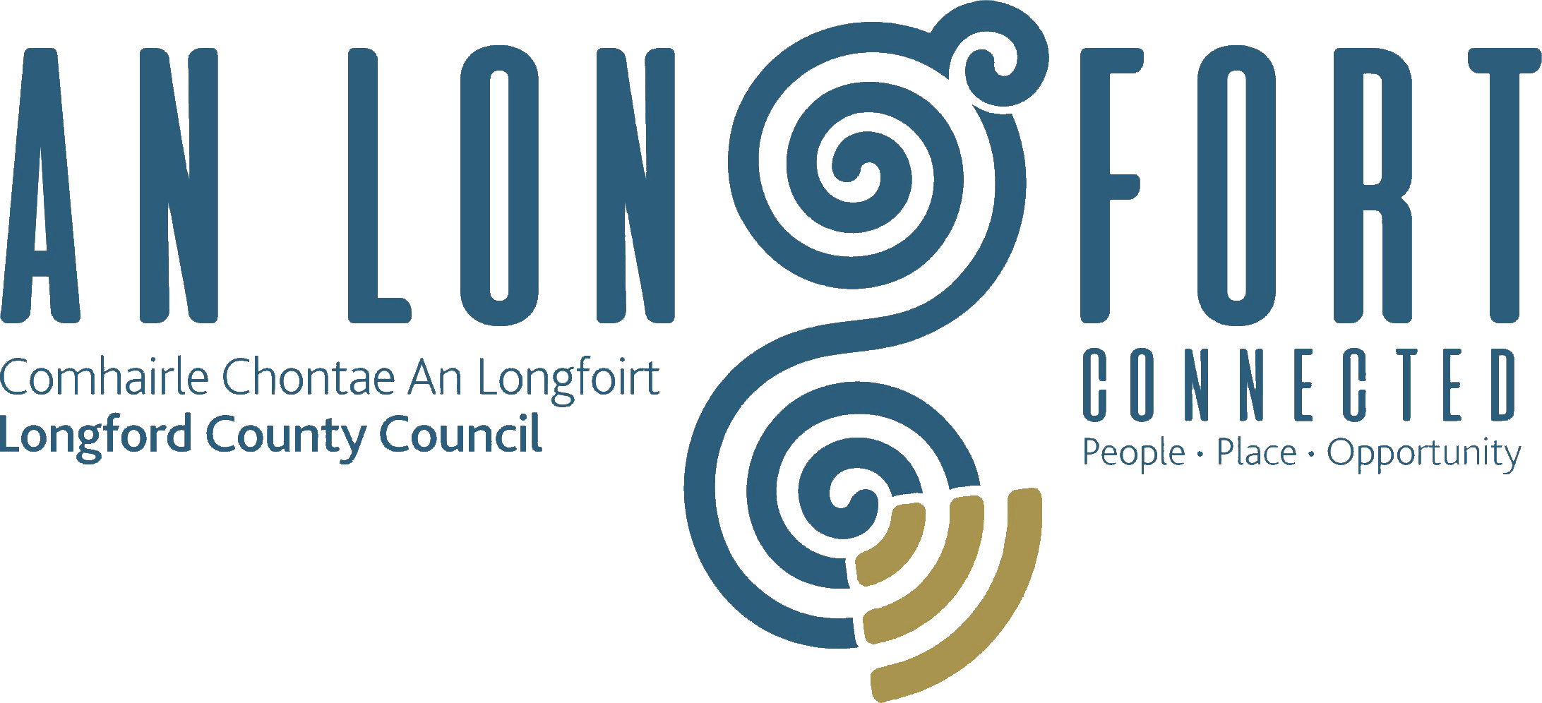

BALLYMAHON MUNICIPAL DISTRICT

Minutes of 2023 Annual Meeting of Ballymahon Municipal District held in the
Ballymahon Library and via Microsoft Teams
On Thursday, 22 June 2023 at 4pm.
__________________________________________________________________________

CATHAOIRLEACH: Councillor Paul Ross

MEMBERS PRESENT: Councillors – Colm Murray, Mark Casey, Gerard Farrell,
Pat O’Toole and Mick Cahill

IN ATTENDANCE: Ms. Samantha Healy, Director of Services
Mr. Gerard Dennigan, A/Meetings Administrator

APOLOGIES: None

A/MEETINGS
ADMINISTRATOR: Mr. Gerard Dennigan

ELECTION OF CATHAOIRLEACH.

On the proposal of Councillor Colm Murray and seconded by Councillor Gerard Farrell that Councillor Paul Ross be elected Cathaoirleach of Ballymahon Municipal District.
Councillor Paul Ross was, thereby, elected Cathaoirleach of Ballymahon Municipal District until the Annual Meeting in 2024.

ELECTION OF LEAS CATHAOIRLEACH:

On the proposal of Councillor Mick Cahill and seconded by Councillor Colm Murray that Councillor Pat O’Toole be elected Leas Cathaoirleach.

Councillor Pat O’Toole was, thereby, elected Leas Cathaoirleach of Ballymahon Municipal District until the Annual Meeting in 2024.

Councillor Ross thanked his proposer and seconder and the Members for electing him as Cathaoirleach of the Municipal District for the coming twelve months and congratulated Councillor Pat O’Toole on being elected Leas Cathaoirleach.

Paul stated that he will work ardently for the Municipal District during his term as Cathaoirleach.

All the Members joined in wishing Councillor Paul Ross every success during his term of office as Cathaoirleach and also congratulated Councillor Pat O’Toole.

Councillor Pat O’Toole thanked his proposer and seconder and congratulated Councillor Ross on being elected Cathaoirleach.

Director of Services, Samantha Healy on her own behalf and on behalf of the employees of the Council joined with the Elected Members in congratulating Councillor Paul Ross and Pat O’Toole and assured them of the full support of the Municipal District team during their term of office.

ARRANGEMENTS FOR BALLYMAHON MUNICIPAL DISTRICT MEETINGS.

It was agreed that Ballymahon Municipal District Meetings be held on the fourth Thursday of every second month commencing at 4pm.

The Cathoirleach and members thanked the Director, supporting staff and meetings administrator for their outstanding service to the Ballymahon MD.

The members unanimously acknowledged the support and assistance provided by the Acting Senior Engineer Brian McNeela in the Ballymahon Municipal District.

This concluded the business of the meeting.

Signed: _________________________
Gerard Dennigan
Meetings Administrator.

Confirmed and adopted at Ballymahon Municipal District Meeting held on the
27 July 2023.

Signed: _______________
Cathaoirleach.

